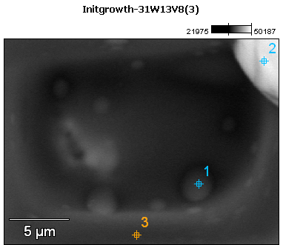

Image Name: Initgrowth-31W13V8(3)

Image Resolution: 512 by 384

Image Pixel Size: 0.04 µm

Acc. Voltage: 13.0 kV

Magnification: 5500

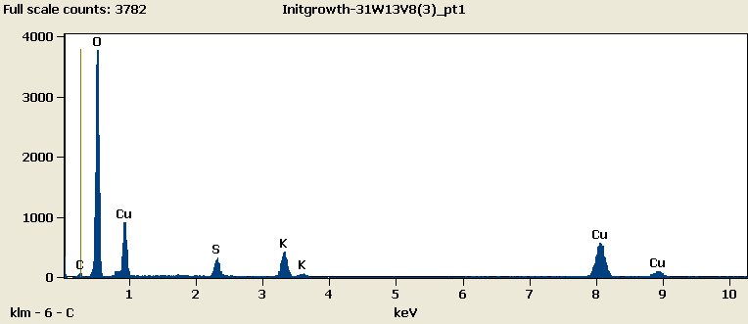

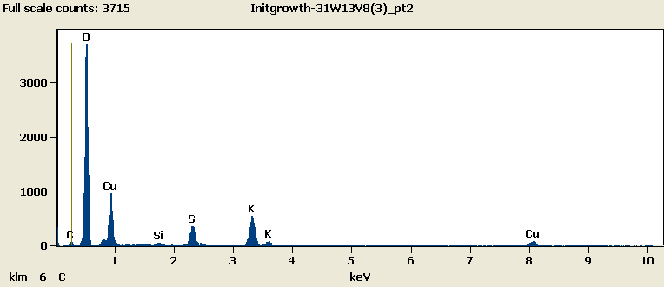

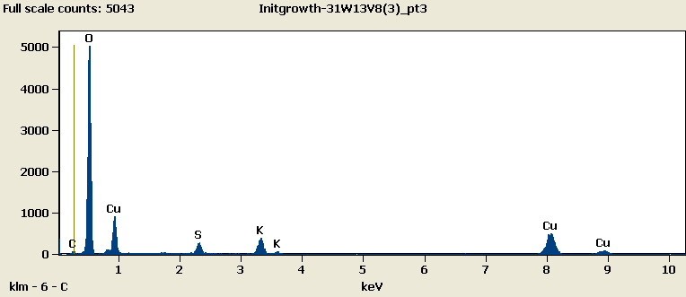

Weight %

|  |  |  |  |  |  |  |
| --- | --- | --- | --- | --- | --- | --- |
|  | ***C-K*** | ***O-K*** | ***Si-K*** | ***S-K*** | ***K-K*** | ***Cu-L*** |
| ***Initgrowth-31W13V8(3)_pt1*** | 2.54 | 54.63 |  | 4.71 | 9.53 | 28.58 |
| ***Initgrowth-31W13V8(3)_pt2*** | 2.41 | 53.04 | 0.32 | 5.20 | 11.23 | 27.79 |
| ***Initgrowth-31W13V8(3)_pt3*** | 2.10 | 60.21 |  | 3.65 | 7.84 | 26.20 |

Weight % Error (+/- 1 Sigma)

|  |  |  |  |  |  |  |
| --- | --- | --- | --- | --- | --- | --- |
|  | ***C-K*** | ***O-K*** | ***Si-K*** | ***S-K*** | ***K-K*** | ***Cu-L*** |
| ***Initgrowth-31W13V8(3)_pt1*** | ±0.20 | ±0.36 |  | ±0.15 | ±0.25 | ±0.44 |
| ***Initgrowth-31W13V8(3)_pt2*** | ±0.19 | ±0.35 | ±0.05 | ±0.15 | ±0.25 | ±0.43 |
| ***Initgrowth-31W13V8(3)_pt3*** | ±0.19 | ±0.34 |  | ±0.14 | ±0.23 | ±0.42 |

# Cations

|  |  |  |  |  |  |  |
| --- | --- | --- | --- | --- | --- | --- |
|  | ***C-K*** | ***O-K*** | ***Si-K*** | ***S-K*** | ***K-K*** | ***Cu-L*** |
| ***Initgrowth-31W13V8(3)_pt1*** | 0.00 | 0.00 |  | 0.00 | 0.00 | 0.00 |
| ***Initgrowth-31W13V8(3)_pt2*** | 0.00 | 0.00 | 0.00 | 0.00 | 0.00 | 0.00 |
| ***Initgrowth-31W13V8(3)_pt3*** | 0.00 | 0.00 |  | 0.00 | 0.00 | 0.00 |